We can use Thompson's Construction to find out a Finite Automaton from a Regular Expression. We will reduce the regular expression into smallest regular expressions and converting these to NFA and finally to DFA.

Some basic RA expressions are the following −

***Case 1*** − For a regular expression ‘a’, we can construct the following FA −

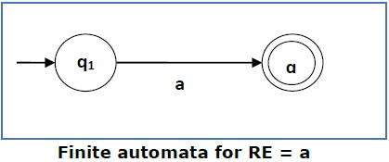

***Case 2*** − For a regular expression ‘ab’, we can construct the following FA −

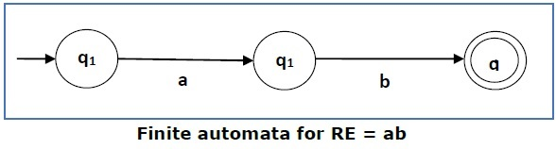

***Case 3*** − For a regular expression (a+b), we can construct the following FA −

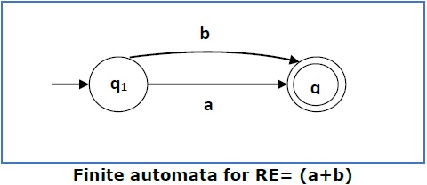

***Case 4*** − For a regular expression (a+b)*, we can construct the following FA −

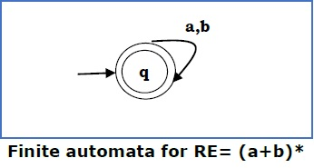

Method

**Step 1** Construct an NFA with Null moves from the given regular expression.

**Step 2** Remove Null transition from the NFA and convert it into its equivalent DFA.

**Problem**

Convert the following RA into its equivalent DFA − 1 (0 + 1)* 0

***Solution***

We will concatenate three expressions "1", "(0 + 1)*" and "0"

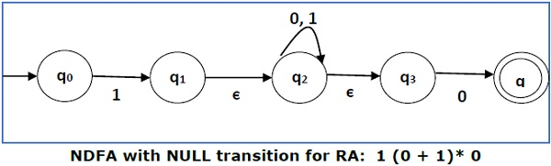

Now we will remove the **ε** transitions. After we remove the **ε** transitions from the NDFA, we get the following −

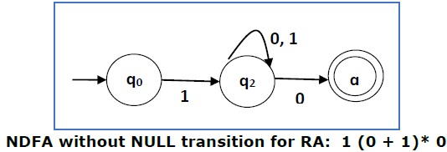

It is an NDFA corresponding to the RE − 1 (0 + 1)* 0. If you want to convert it into a DFA, simply apply the method of converting NDFA to DFA discussed in Chapter 1.

Finite Automata with Null Moves (NFA-ε)

A Finite Automaton with null moves (FA-ε) does transit not only after giving input from the alphabet set but also without any input symbol. This transition without input is called a **null move**.

An NFA-ε is represented formally by a 5-tuple (Q, ∑, δ, q0, F), consisting of

* **Q** − a finite set of states
* **∑** − a finite set of input symbols
* **δ** − a transition function δ : Q × (∑ ∪ {ε}) → 2Q
* **q0** − an initial state q0 ∈ Q
* **F** − a set of final state/states of Q (F⊆Q).

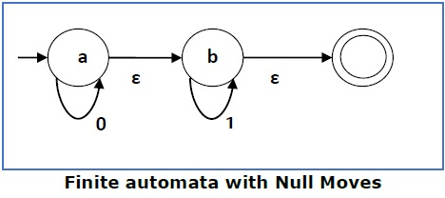

The above **(FA-ε)** accepts a string set − {0, 1, 01}

Removal of Null Moves from Finite Automata

If in an NDFA, there is ϵ-move between vertex X to vertex Y, we can remove it using the following steps −

* Find all the outgoing edges from Y.
* Copy all these edges starting from X without changing the edge labels.
* If X is an initial state, make Y also an initial state.
* If Y is a final state, make X also a final state.

**Problem**

Convert the following NFA-ε to NFA without Null move.

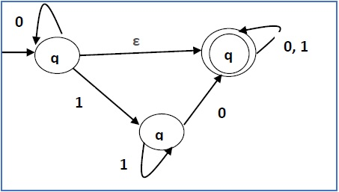

***Solution***

**Step 1** −

Here the ε transition is between **q1** and **q2**, so let **q1** is **X** and **qf** is **Y**.

Here the outgoing edges from qf is to qf for inputs 0 and 1.

**Step 2** −

Now we will Copy all these edges from q1 without changing the edges from qf and get the following FA −

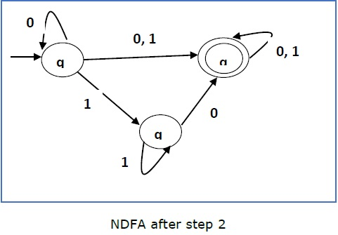

**Step 3** −

Here q1 is an initial state, so we make qf also an initial state.

So the FA becomes −

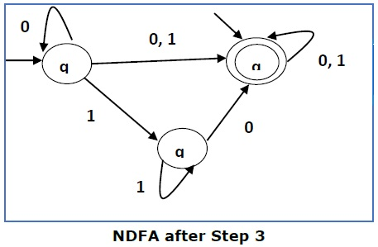

**Step 4** −

Here qf is a final state, so we make q1 also a final state.

So the FA becomes −

